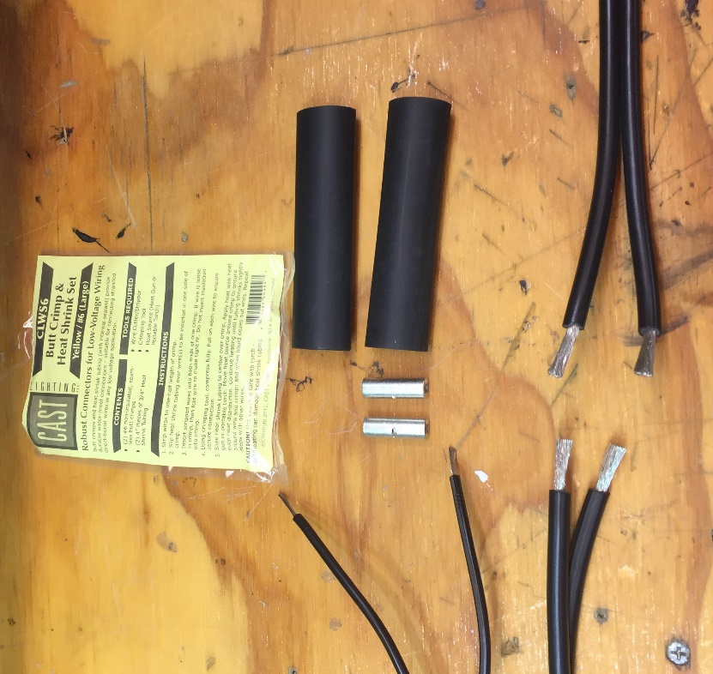

Splice Connection:

One CLWS6 Splice Kit Includes two #6 Barrel Crimps Butt Splice. Two ¾” x 4” Heat Shrink With Internal Sealant

#8-2 Wire and #16-2 wire to feed CPL1 Fixture

Step One: Strip Wires: Careful not to strip any .010” Strands.

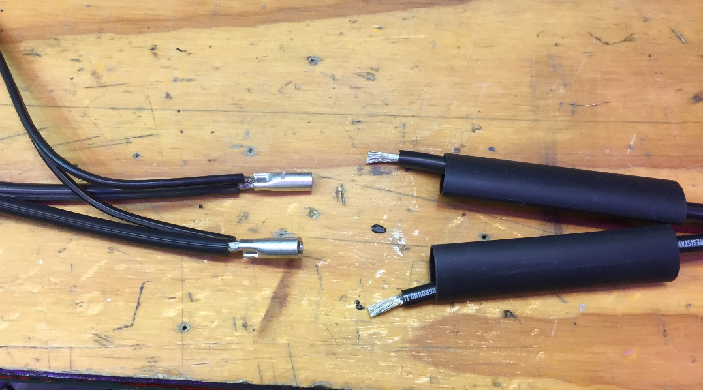

Step Two : Crimp “Downstream” Wires in #6 Barrel Crimp. (i.e #8 and #16)

Step Three: Place heat shrink over “Upstream” each #8-2 Wires

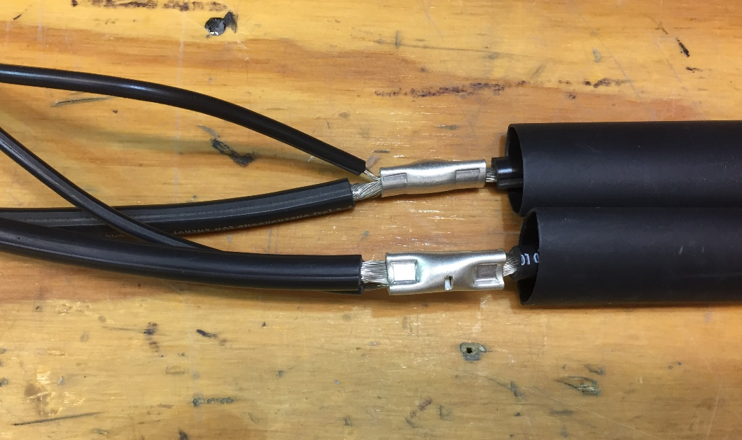

Step Four: Crimp “Upstream” side of barrel crimp

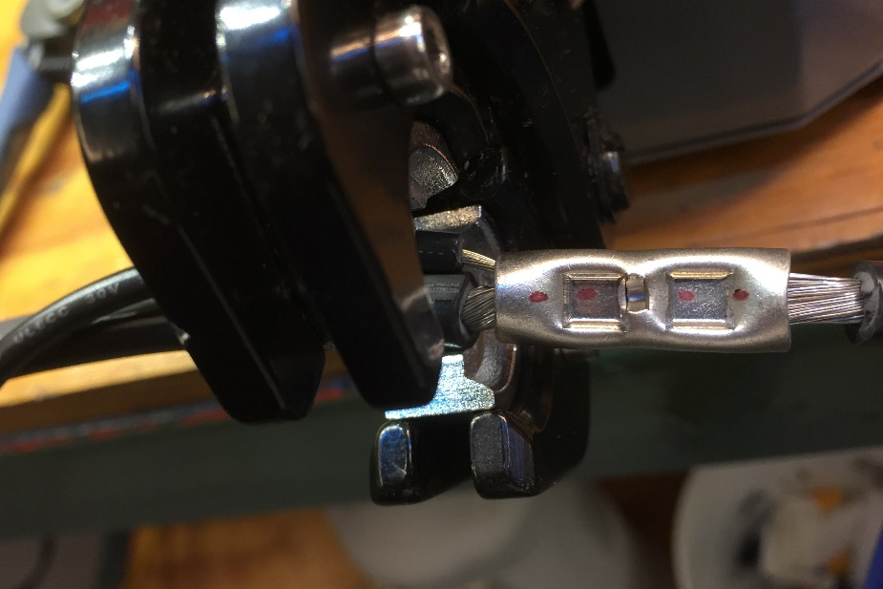

A note on using Pneumatic Crimping or manual crimping Machine:

HIT the crimp connection two to three times with crimping machine to insure a TIGHT crimp connection

Photo shows one hit

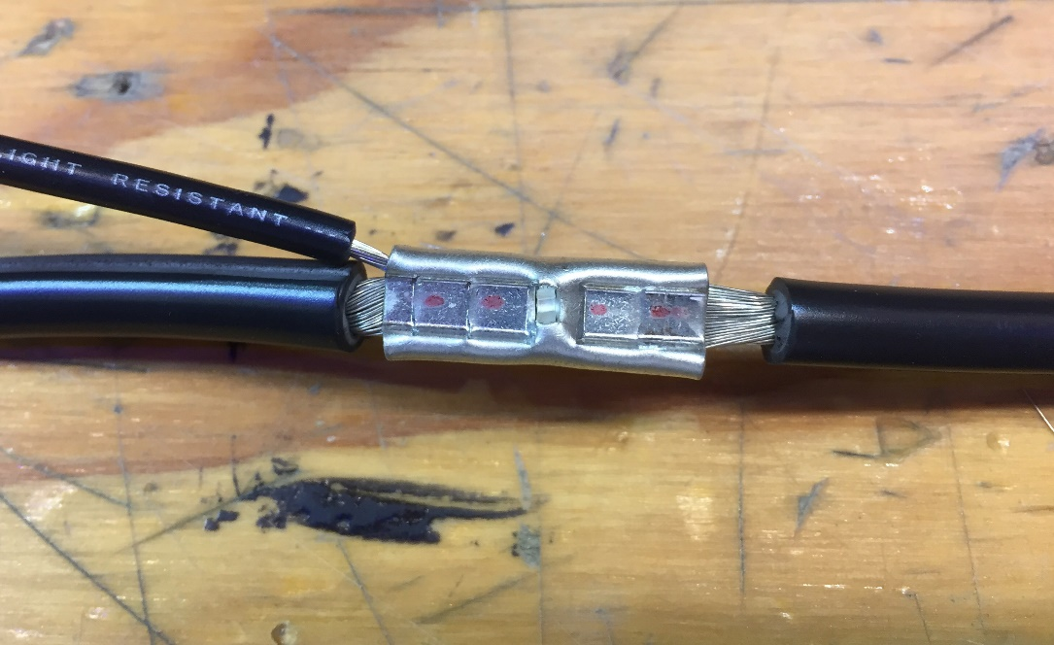

This is the crimp connection you want. This has been hit three times with a pneumatic crimping machine. This is not coming apart ! SOLID

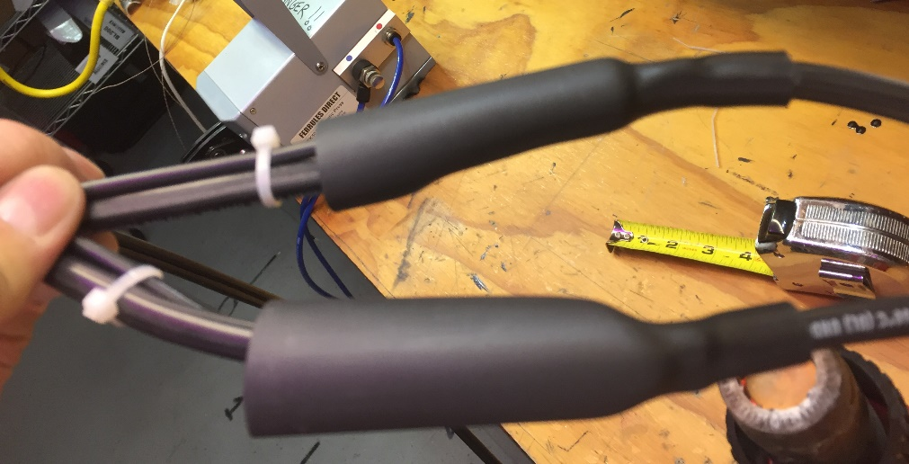

Put heat shrink over crimp connection So upstream heat shrink covers 3/8” to ½” over the insulation of the #8 wire. Remaining heat shrink, 3-1/2” covers splice and two wires.

Zip tie or tape to keep wires together during heating

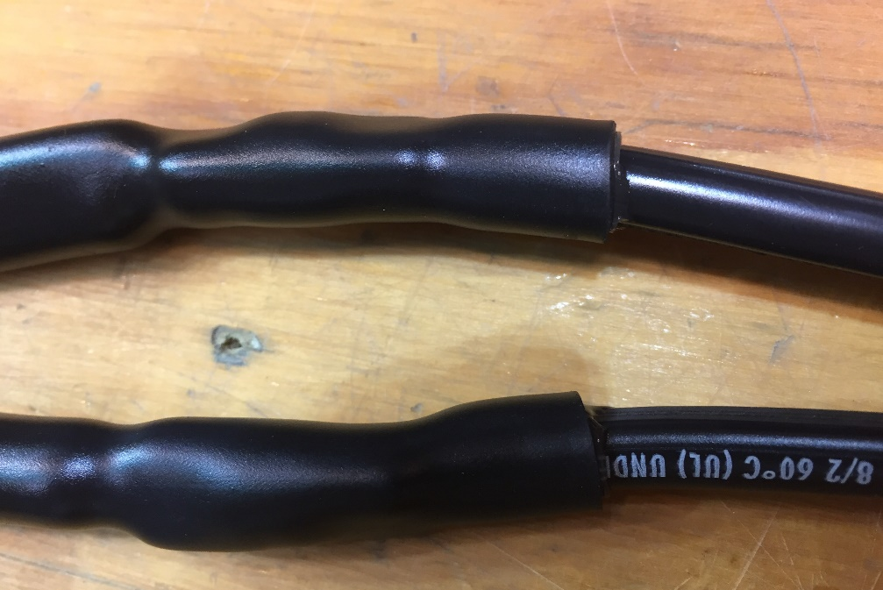

EXTREMELY IMPORTANT !! PAY ATTENTION. YOU MUST HEAT THE HEAT SHRINK UNTIL YOU SEE THE EXTERIOR OF THE HEAT SHRINK IS SHINY AND THE MATERIAL HAS FULLY SHRUNK DOWN AND YOU VISIBLY SEE THE INTERNAL SEALANT OOZING FROM BOTH ENDS. This takes a good minute and a half to fully heat the material and release the internal sealant fully.

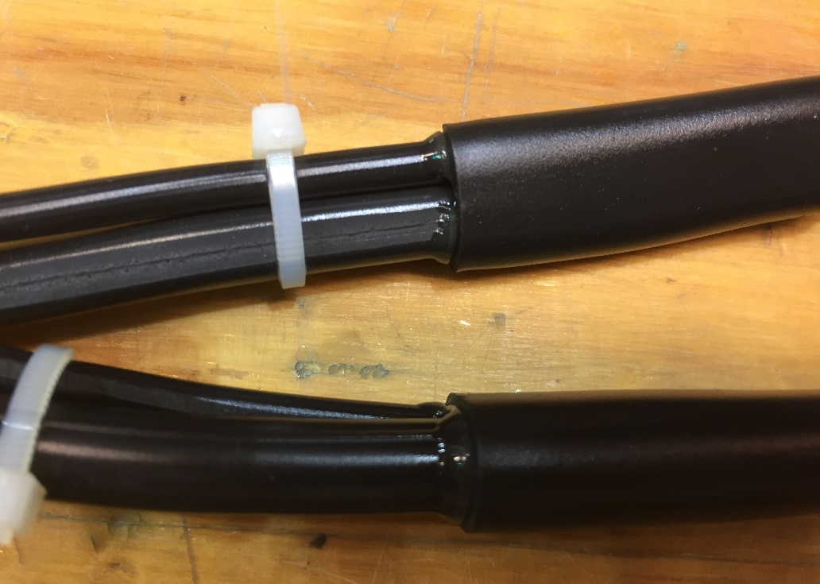

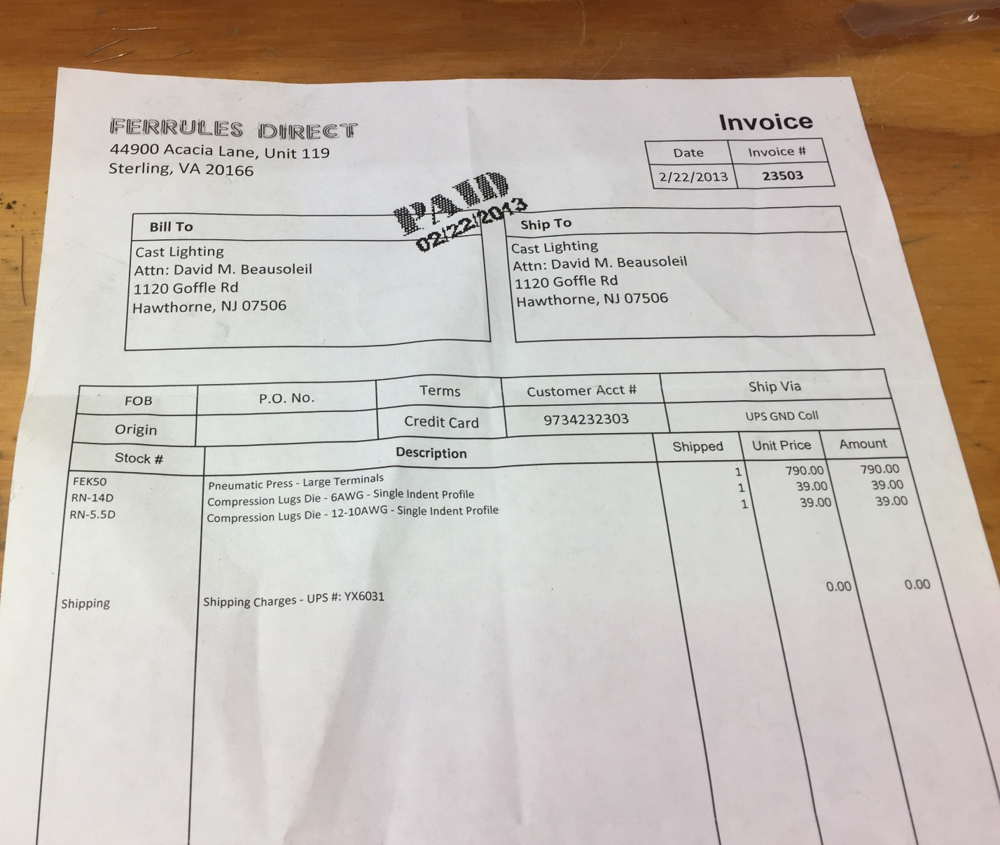

Where you can order a pneumatic crimping machine if you want to own one of these babies. You need to purchase the crimping dies separate. RN-14D for the #6 Die